CS Bridge Module 13 Searching

1. Searching

1.1 CS Bridge: Searching


1.2 The Searching Problem
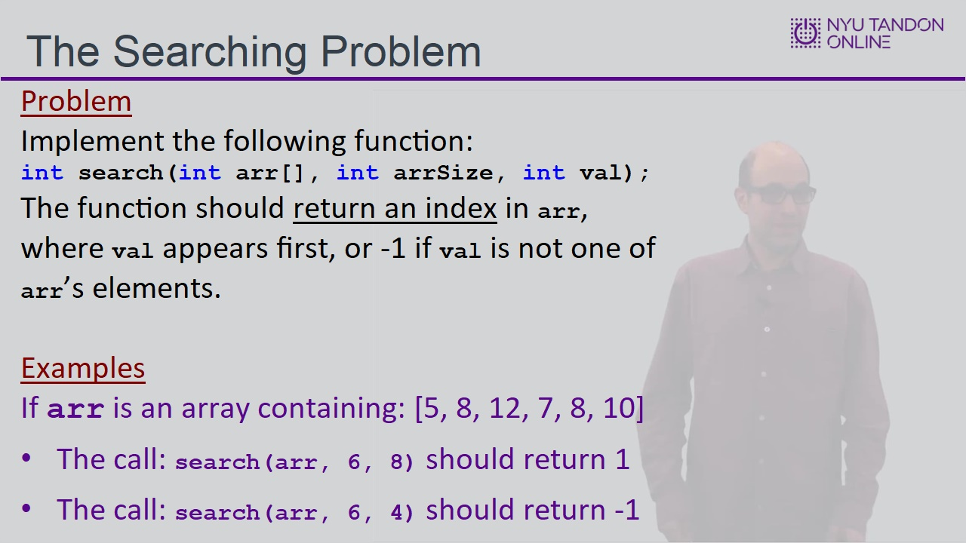

1.3 Searching Code Sample
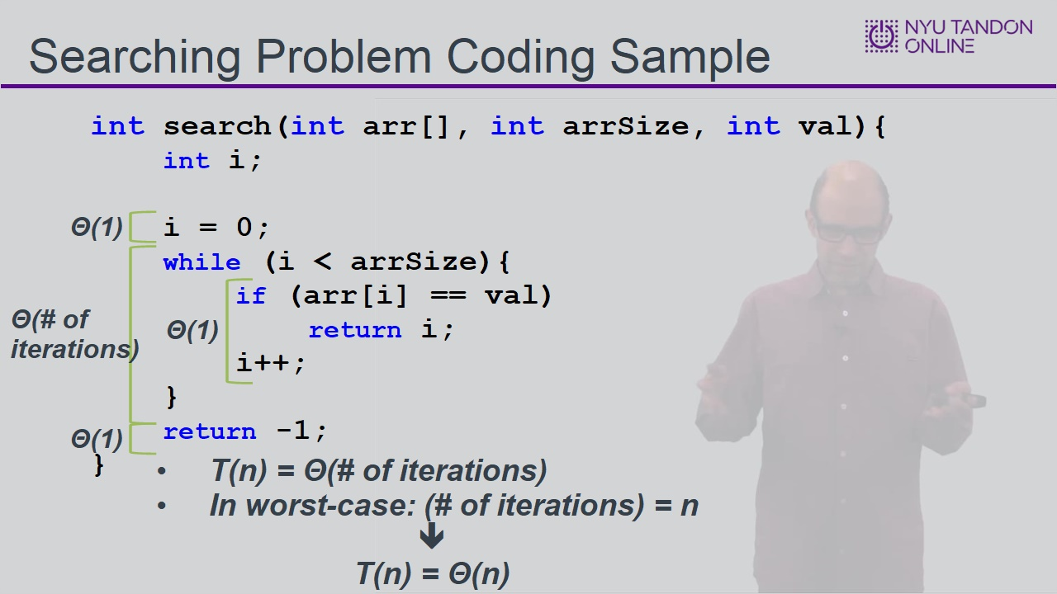

1.4 The Sorted-Search Problem
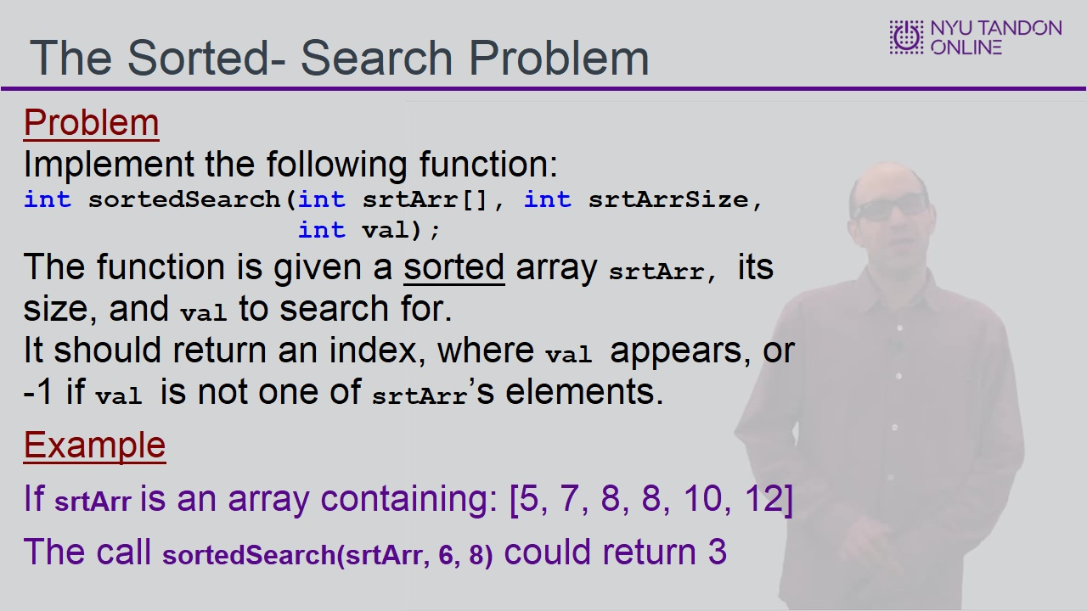

1.5 The Sorted-Search Problem
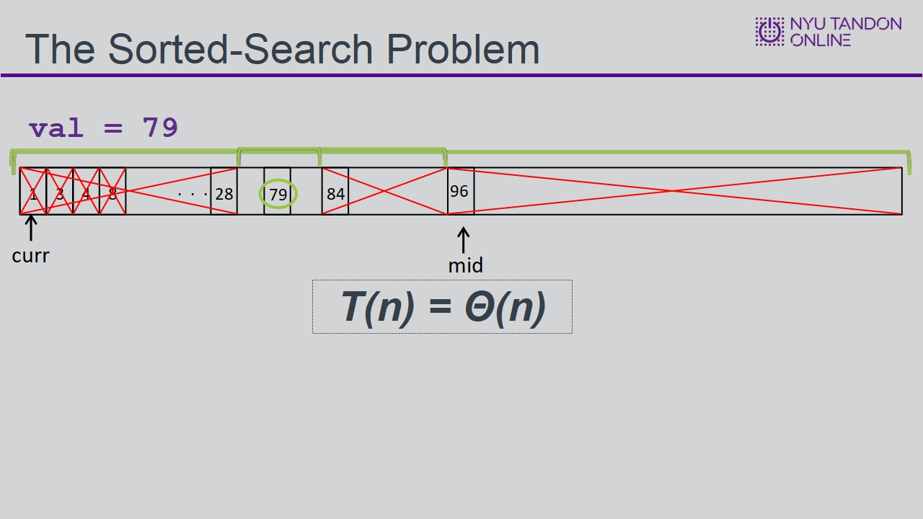

1.6 Sorted Search Implementation
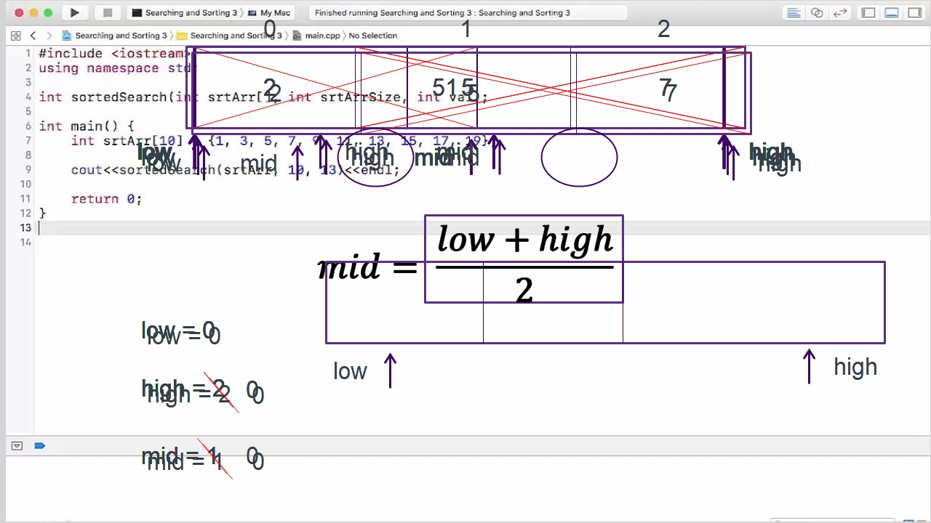

1.7 Implementation
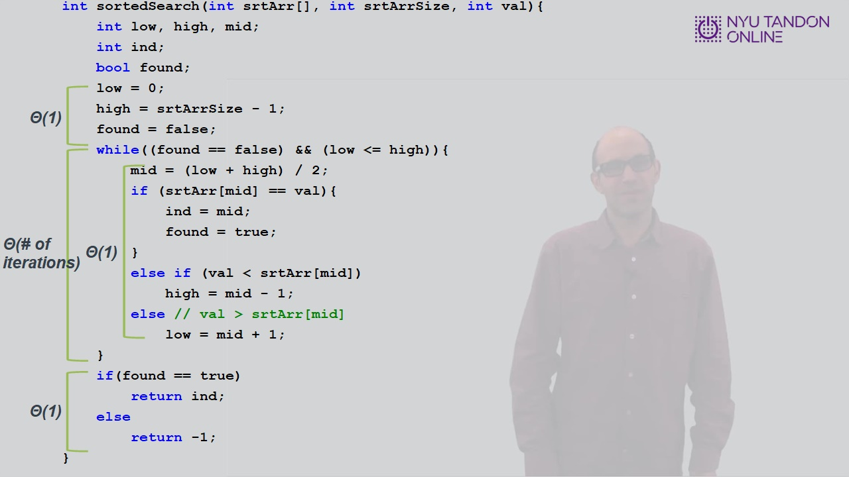

1.8 The Sorted-Search Problem
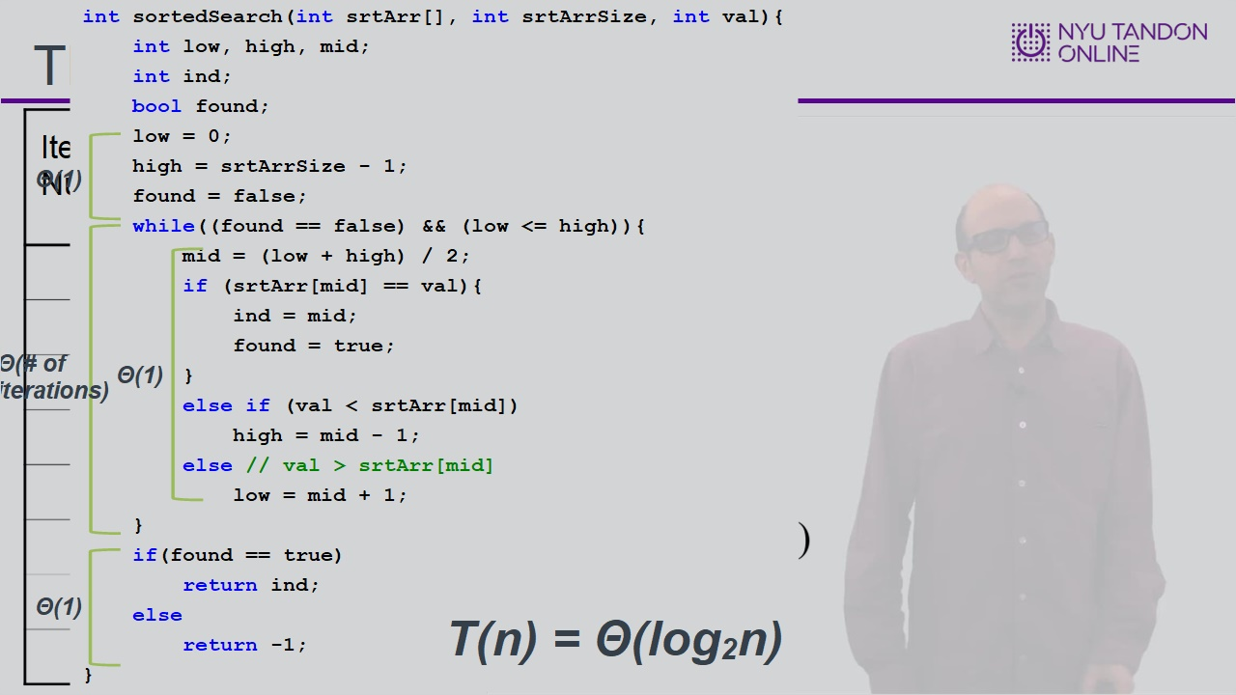

1.9 Linear vs Logarithmic
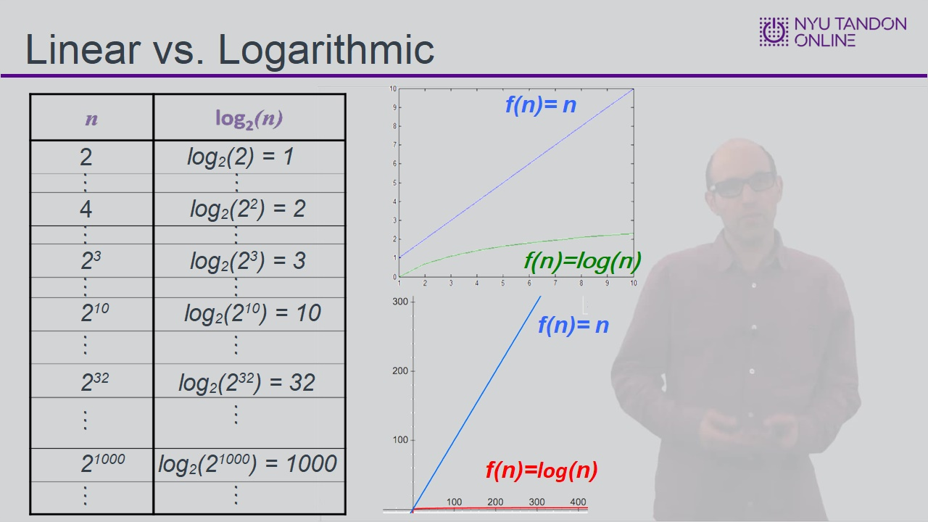

1.10 Knowledge Check
(Multiple Choice, 10 points, 5 attempts permitted)
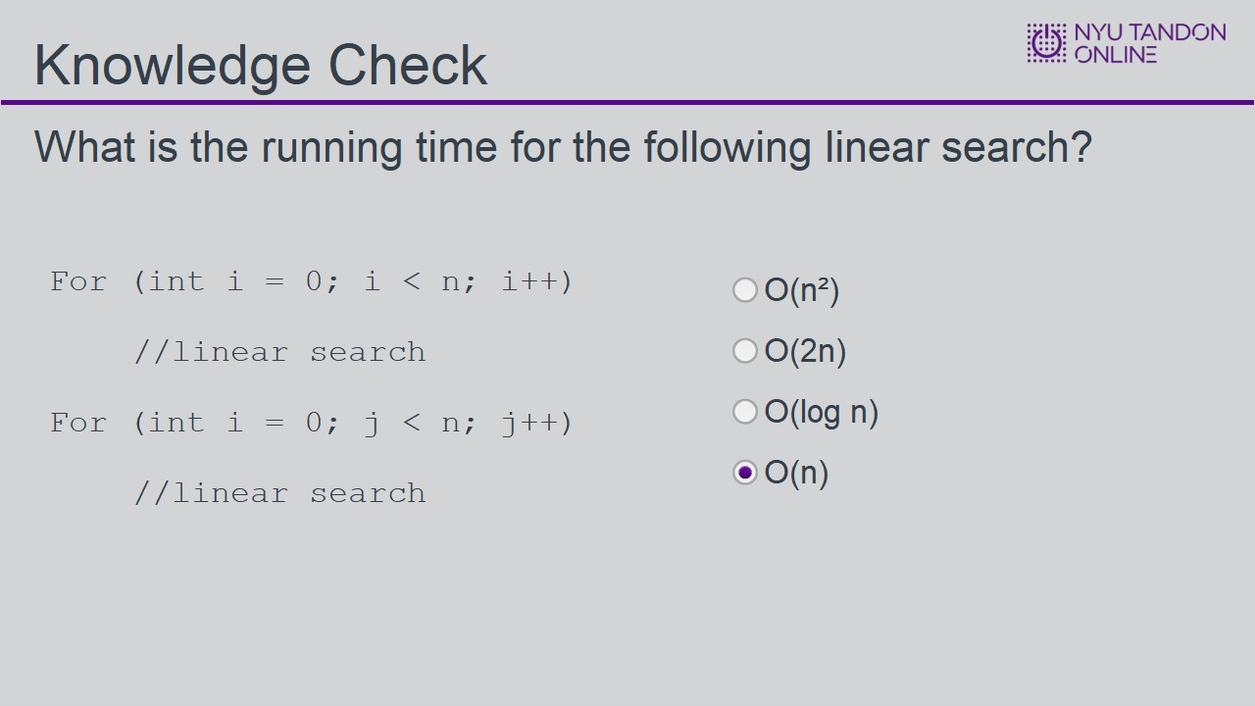
Correct | Choice
 | O(n²)
 | O(2n)
 | O(log n)
X | O(n)
Feedback when correct:
That's right! You selected the correct response.
Feedback when incorrect:
You did not select the correct response.

Correct (Slide Layer)
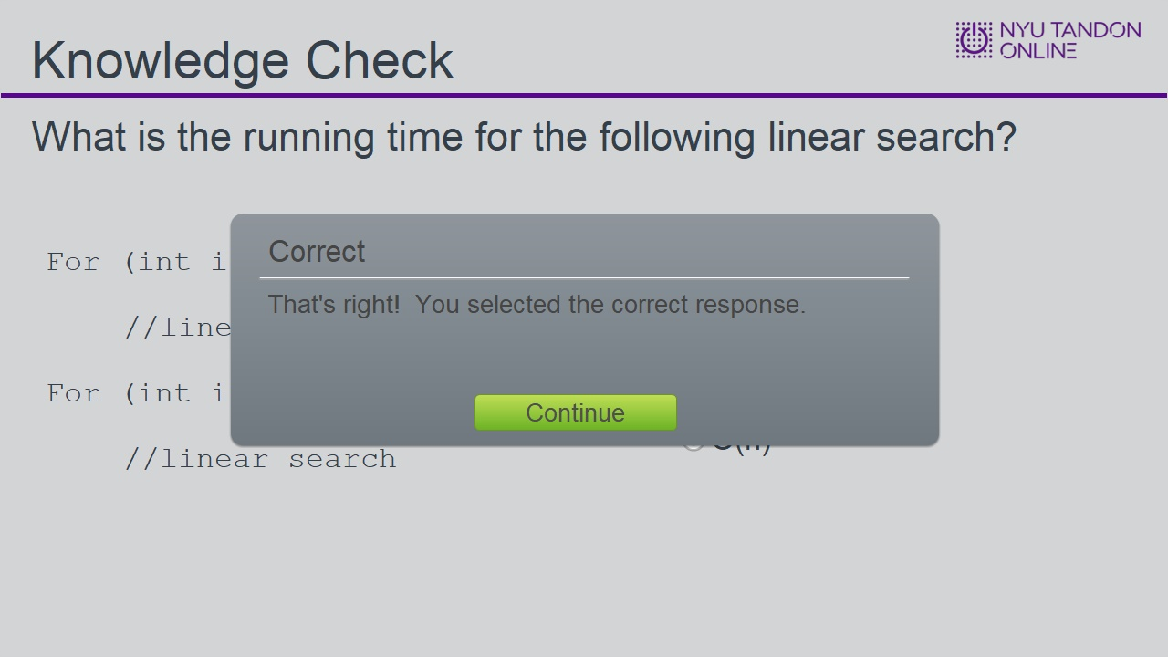

Incorrect (Slide Layer)
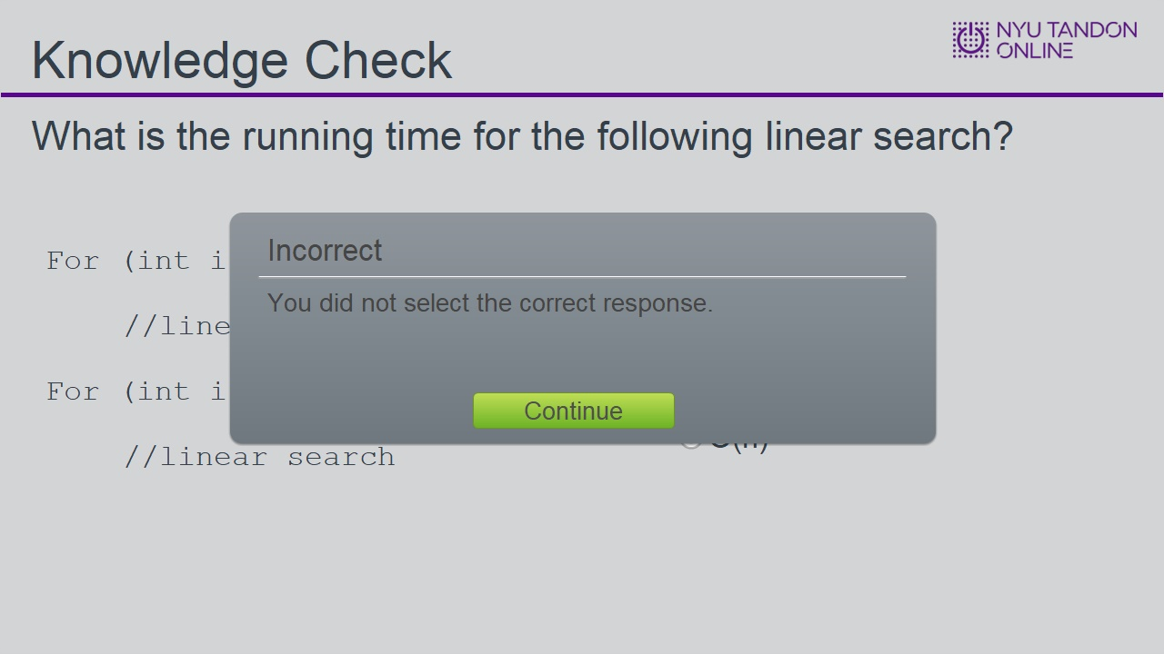

Try Again (Slide Layer)
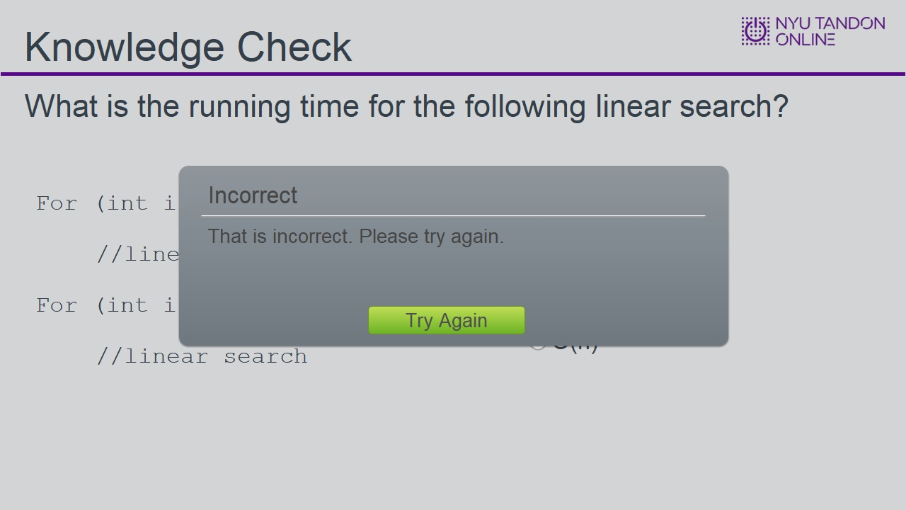

1.11 Knowledge Check
(Multiple Choice, 10 points, 4 attempts permitted)
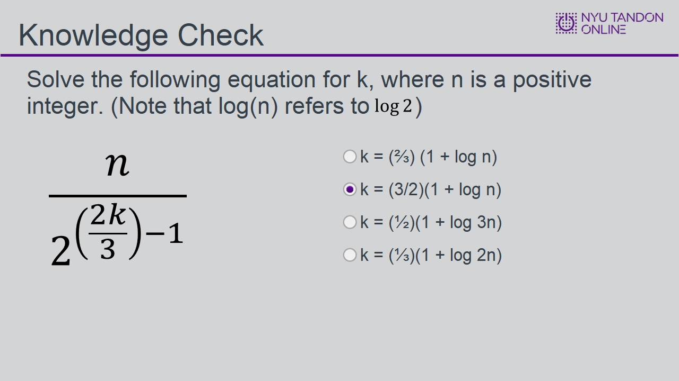
Correct | Choice
 | k = (⅔) (1 + log n)
X | k = (3/2)(1 + log n)
 | k = (½)(1 + log 3n)
 | k = (⅓)(1 + log 2n)

Feedback when correct:
That's right! You selected the correct response.
Feedback when incorrect:
You did not select the correct response.

Notes:

Correct (Slide Layer)
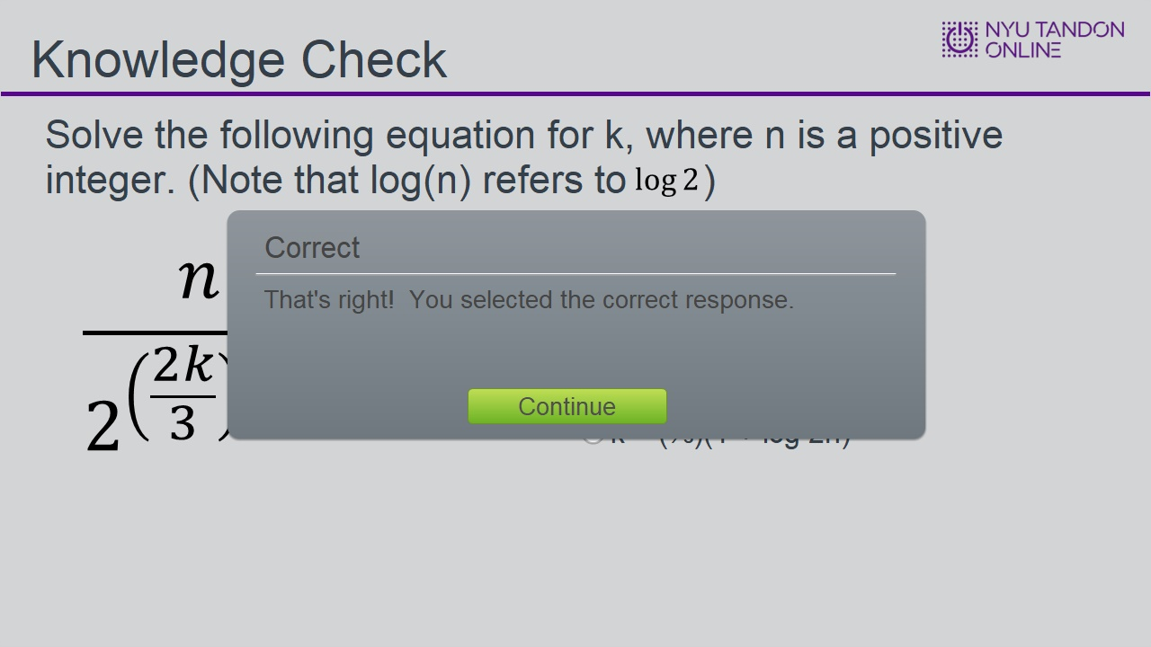

Incorrect (Slide Layer)
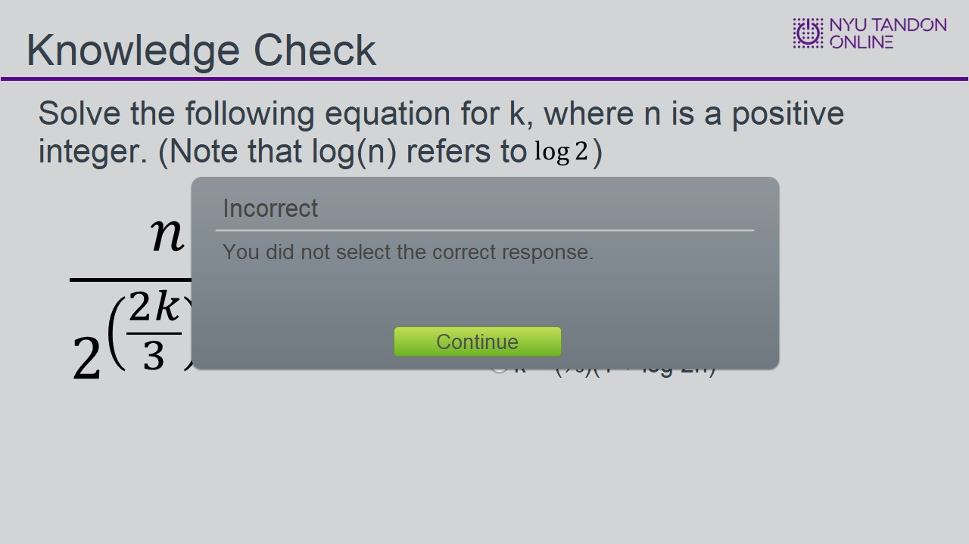

Try Again (Slide Layer)
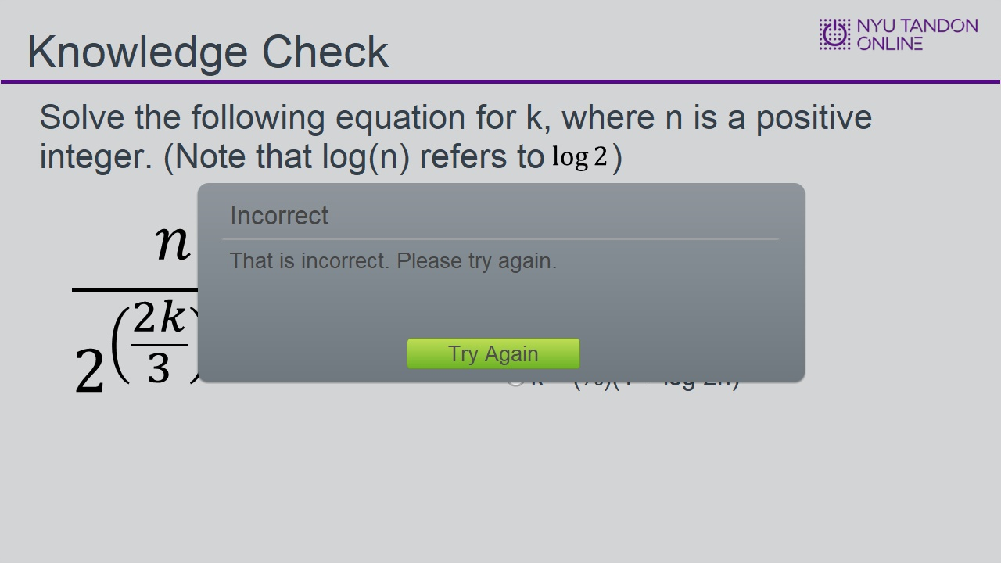

1.12 End of Module


